**Main Home Page for**

**Anyone Landing on the Site**

**(not logged in)**

**High Level Outline of Home Page Anyone Can Land On**

Should be clean, concise, have pictures, have color, and not crowded with stuff.

1. Some basic information about who we are & a “join us” button
2. Link to find online classes
3. Links to find local activities & classes – at first just for Atlanta, GA and Austin, TX
4. Link for businesses that want to enter their events

Other parts:

* Navigation bar or drop down menu at the top.
* Prominent “login” and “create an account” buttons
* Maybe a tag line at the top

*Notes:*

1. *The Social Rugrats site is a good example of a format I like*
2. *See my drawings on the following pages*
3. *See my reviews of other event home pages I found online (at end of this document)*

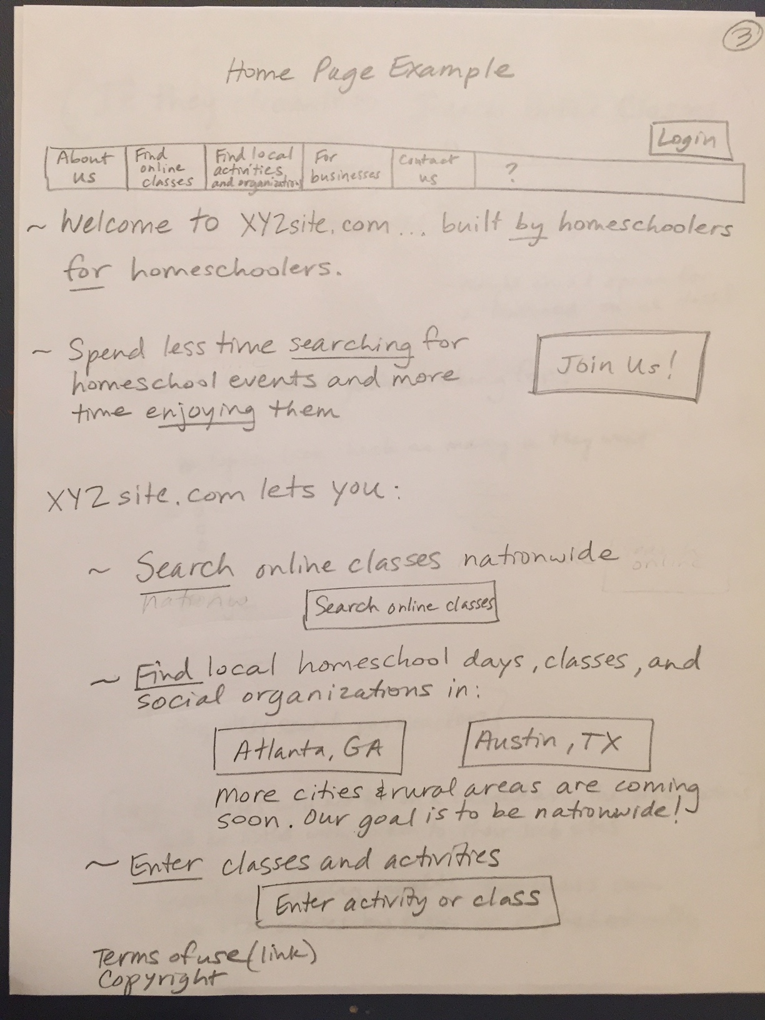  
From the previous drawing, if a user clicks “Search Online Classes”, they may see something like this:

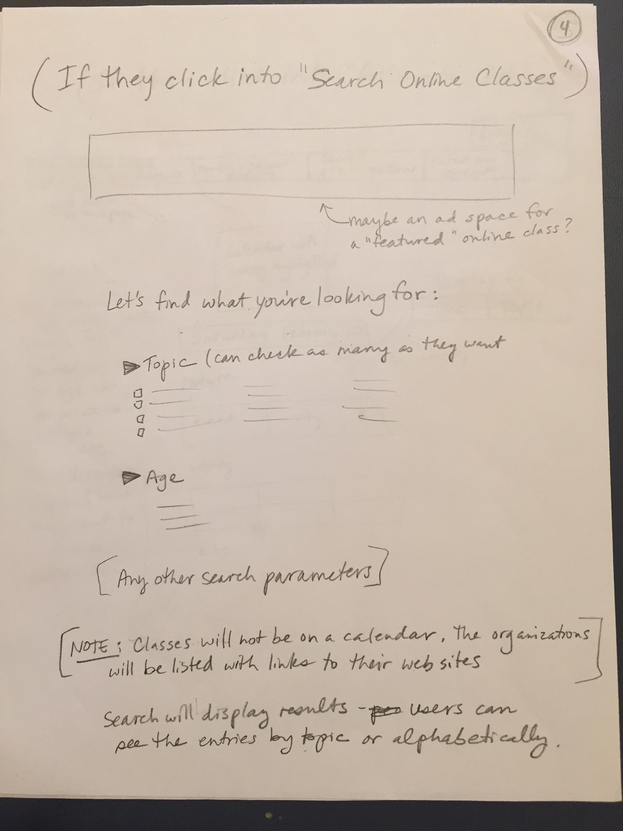

From the main page (first picture above), if a user clicks into “Atlanta, GA”, they may see something like this. *[See my notes on what I like and don’t like about event listings in current web sites.]*

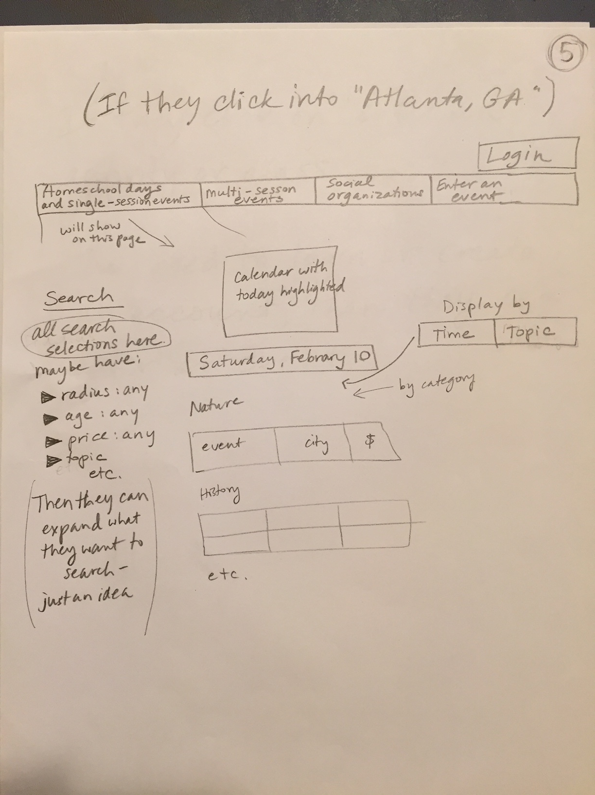

From the main page (first picture above), if a user clicks into “Enter an Activity or Class”, they will be directed to “Log In” or “Create an Account”. Only businesses and individuals who are logged in can create events.

**Main Home Page for**

**Homeschoolers who**

**are Logged in**

**High Level Outline for Homeschool Users who Log In**

The main things I want homeschool families to see when they log in are:

1. **New activities** that have been posted. (I think this will keep them coming back to the site frequently)

* For their “favorite” organizations – past 7 days
* For all organizations – past 48 hours

1. Their **saved activities** *(ones they marked that their interested in or going to)*

* Happening in the next 7 days
* All saved activities

1. Info from their “**Social Center**”

* New messages
* New invitations *(it would be great if users could tag friends who may be interested in an event)*

Maybe these 3 sections could be separated by graphics or colors. And they could “expand” the info as they want. (See my drawing on the next page. When they click on an arrow, the info would expand. They could click it again to hide it.)

**OR**

The info could be in the navigation bar and clicked easily through like my second drawing.

One possible format using expandable arrows:

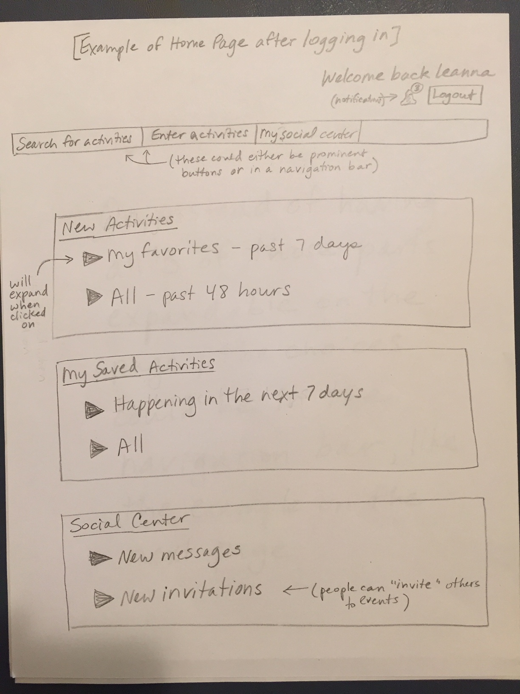

Another possible format using the navigation bar instead of expandable arrows:

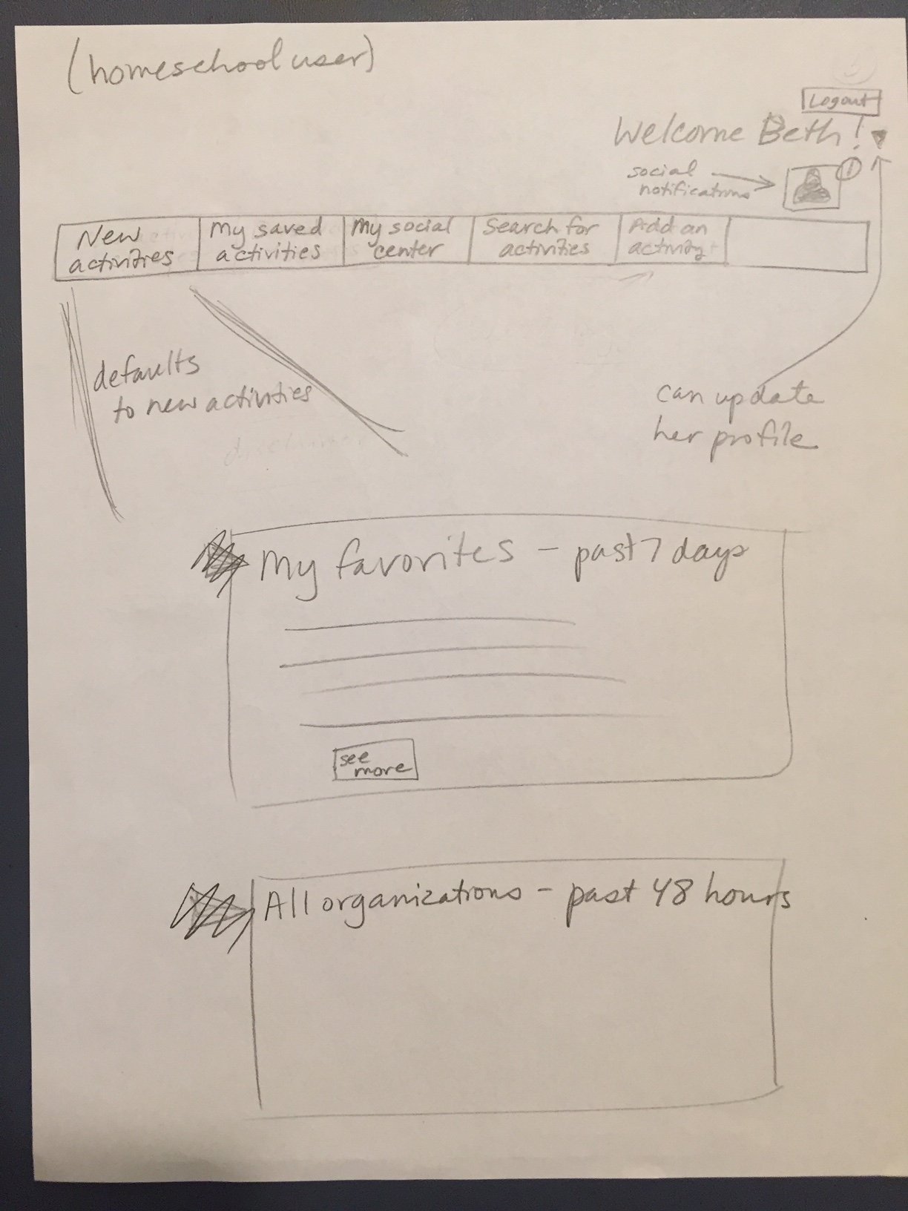

**Main Home Page for**

**Businesses who**

**are Logged in**

**High Level Outline for Businesses who Log In**

Some businesses will be entering events while others will enter physical classes or online classes.

Similar to the 2 types of home pages I drew for homeschoolers, I have different thoughts about using 1) expandable arrows or 2) toolbar navigation.

The main things I want businesses to see when they log in are:

1. Big button for **“Add a New Activity”**
2. See a list of their **upcoming events**, with an “Edit” button so they can easily make changes.
3. See their listings for **classes**
4. Be able to access their **Past Events** *(and maybe an easy way to “repost” it & change the date if it’s happening again)*
5. See and easily change their **Organizational Profile**.

One possible format using expandable arrows:

Note: maybe instead of separating “event” listings and “class” listings, we just put them together and call them the businesses’ “postings”, like “Our Current Postings”.

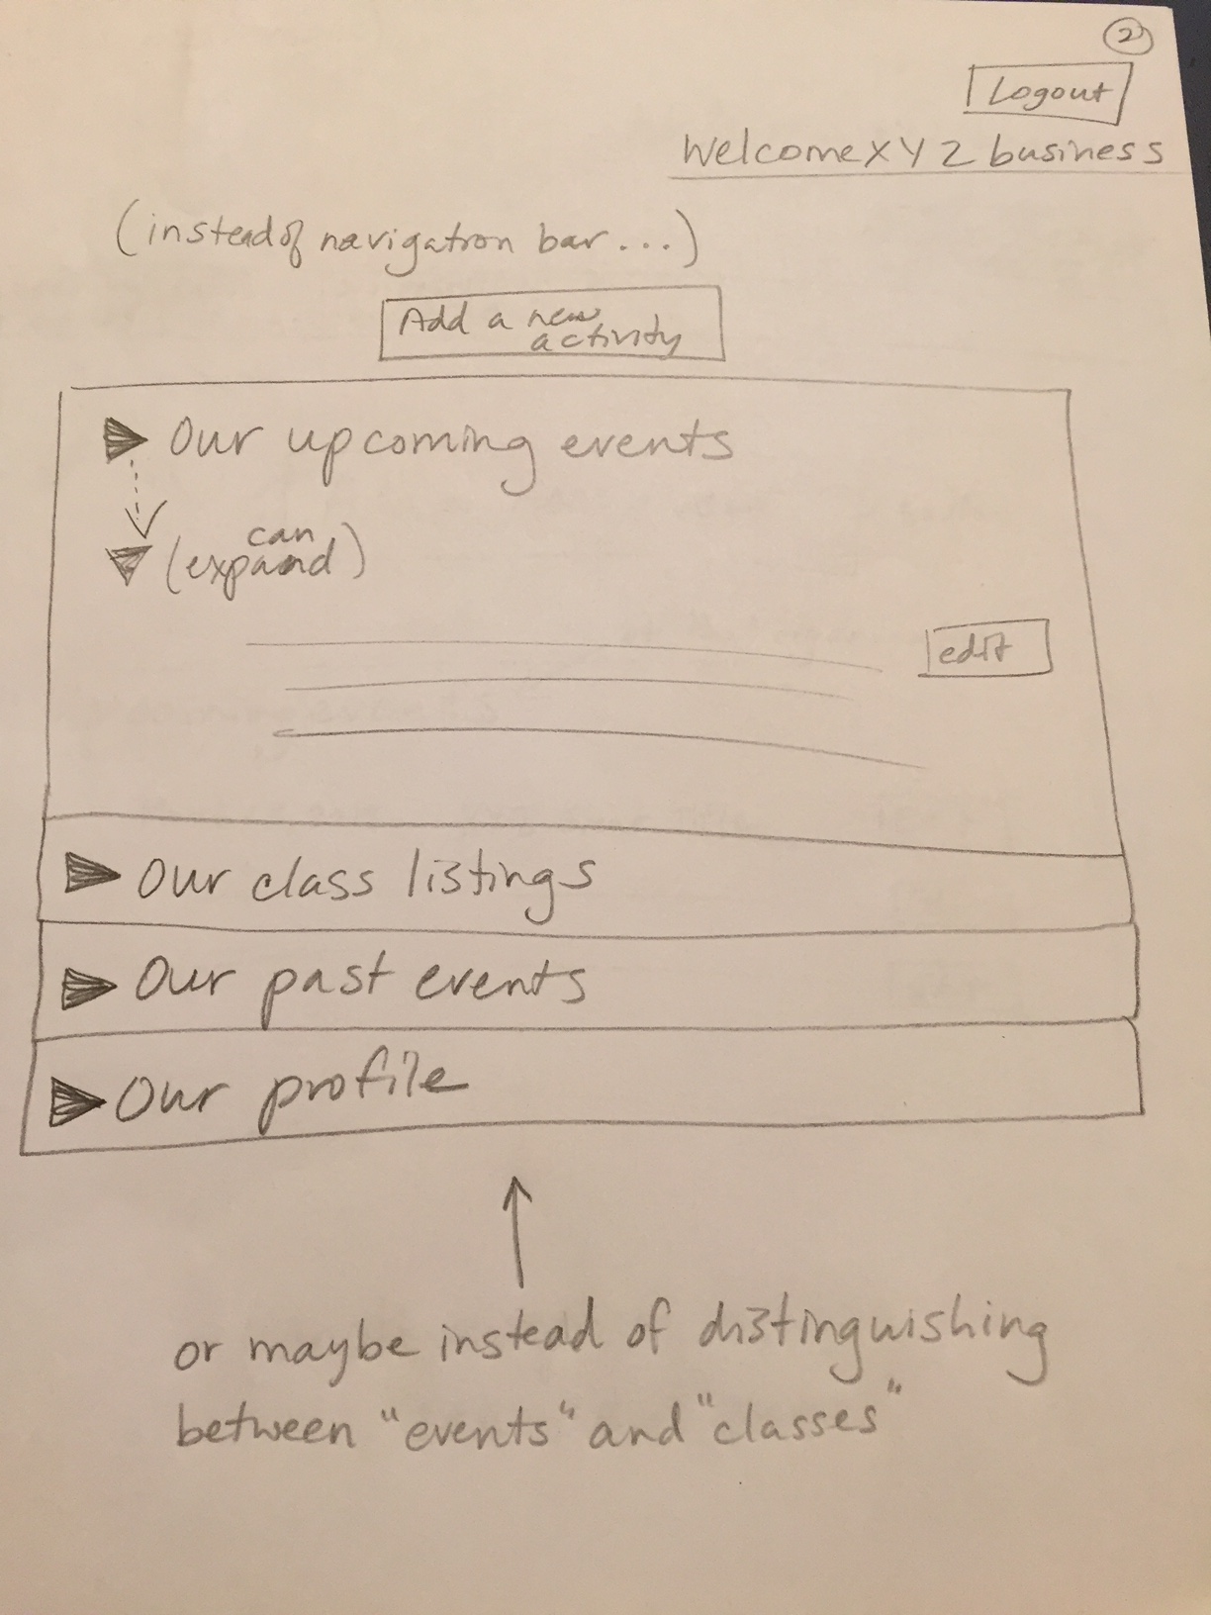

Another possible format using the navigation bar instead of expandable arrows:

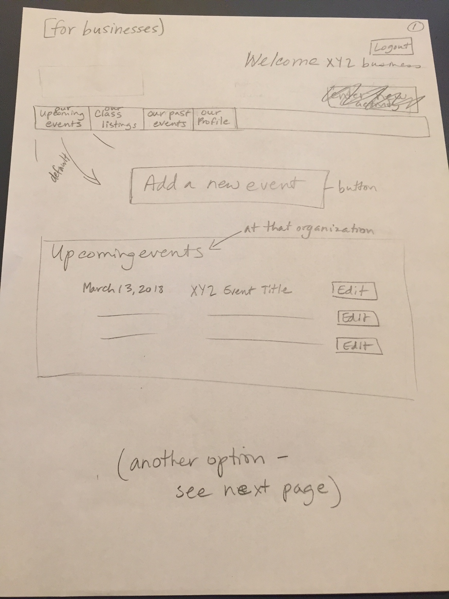

**My Thoughts about Various**

**Event Web Pages**

***Some of my comments are about the***

***main home page, while other comments are about the format of event listings.***

**Social Rugrats**

<https://www.socialrugrats.com>

* Pros:
  + This is such a clean home page. This is like what I want. Simple statements and pictures.
  + The vibrant colors make it seem “alive” and active. Obvious “join” button.
  + It is obvious that they are only in certain cities and that they are coming to more cities soon.
* Cons:
  + A strange thing is that once I signed in on my computer, I can’t see the main home page again. And I can’t find a way to “sign out” of my account. I need to view the main home page from another computer.

**Event Website in Austin, TX**

<https://freefuninaustin.com>

* This is an example of what I **DON’T** want our home page to look like. Very overwhelming. We will not have articles or blogs on our site now (maybe in the future). Our focus is event listings and I want us all to keep that focus.
* I like having the ads the same size down the right-hand side of the page rather than mixed in with the general info.

<https://freefuninaustin.com/calendar/>

* Pros:
  + I like the “list view” here better than the “picture views” with event names in small letters like on the Social Rugrats site. The pictures on the Rugrats site distract me.
  + It’s interesting how the dates are lined up horizontally and how you clearly see what date you are looking at (though the date is VERY huge). But I like calendar views too.
* Cons:
  + The writing is WAY too miniscule
  + No identifying markers for categories of events. They just all blend together. So it is overwhelming and difficult to sort through.

**Event Website in Boston, MA**

<https://www.bostoncentral.com/events.php>

* Pros:
  + I **REALLY** like how these events are already separated by topic, and how the town and $$ are clearly marked. Much easier to read than a mishmash of events sorted only by time.
  + The events take up single lines. I feel like it’s much easier for my eye to skim down the list. I like this better than seeing giant pictures or long descriptions of events next to each event.
  + I like the titles of their topics (science & technology, theaters & shows, etc.). I’m going to refer to this site when we finalize our list of topics.
  + I **REALLY** like how they have lists of organizations by topic (at the bottom of the page). If I was a visitor to Boston and wanted to see all the zoos or aquariums… boom! There they are. This may be a good way to list the organizations who login with us, though it’s sort of “lost” down at the bottom of the page
  + Overall, I like this event list view a lot.
* Cons:
  + The calendar is at the top of the page but mashed in between ads. That’s distracting.
  + Having ads on both sides of the page (right & left) is distracting and makes the page look crowded.
  + I can’t tell which of these are ongoing events (like museum exhibits) vs. one-time events. I don’t like that, but I’m not as bothered because at least events are separated by topic.
  + “Submit an event” button is lost in all the ads.
  + It looks like the calendar only goes one month out.

**Event Website in Charlotte, NC**

<http://fun4charlottekids.com/Whats-Happening/>

* Advertising overload.
* At least they described the site

<http://fun4charlottekids.com/calendar/>

* Pros:
  + Disclaimer at the top
  + Color coded events
  + Interesting how a user can switch between the cities of Raleigh and Charlotte, but probably useless to most people because the cities are over 2½ hours apart.
* Cons
  + Overall, don’t like this site
  + This site has a calendar view. Interesting, but not working at all! No need to see events for EVERY day when you can just click on a calendar and get the day you want.
  + If I click “more” on a day, I get expanded event listings with pictures. Overwhelming
  + No search features
  + No categories
  + Some events are purple & others are white. I have no idea what that means.
  + Crowded & overwhelmed with ads

**Another Event Website in Charlotte, NC**

<http://www.charlotteparent.com/CLT/Calendar/>

* Pros:
  + This site is interesting to me. Ads do not overwhelm a user at the top of the page.
  + The events are larger than just a list view, but I don’t feel like it’s as overwhelming as some sites.
  + I like how the tags/topics for each event show up below them. Many events on our website will have multiple tags (an art history museum may have “art” and “history”).
  + I like their search feature on the right, but you can only pick one category at a time. They have “homeschool days” as one of their categories. I wonder how many homeschoolers in Charlotte even know this site exists.
    - The “date range” and start date / end date seems redundant but gives the user a choice I guess.
    - They have all the events “tagged” by topic (like “family”, “educational”, etc.) but people can’t search by topic.
  + Users can submit an event but need to login first.
* Cons:
  + The “submit an event” button is very small & almost unnoticeable.
  + They have “directories” of other resources, but they are down below the ads and easy to miss.
  + The site seems to have “stuff” all over the place. Almost too many choices. Hard to follow. If you click on a link at the top, they have another “daily calendar” that pops up on the righthand side. Overall, hard to navigate with stuff all over the place.

**Event Website in Portland, OR**

<https://www.pdxparent.com>

* Great example of what I **DON’T** want this website home page to look like.
* Difficult to even tell what city this is for!

<https://www.pdxparent.com/events-calendar/>

* Pros:
  + They have a search features, but I don’t love the format.
    - Users can only pick one category at a time
    - The “venue” search has too many options - not necessary
    - Their “ages” and “cost” searches aren’t listed in order (“babies” at the top, “toddlers” at the bottom, & other ages in between… huh?)
* Cons:
  + Ads everywhere
  + Overwhelming list of events. Events tightly packed together.
  + I like the idea of color-coded events, but it’s not helping me on this site.
  + “Submit an event” is tiny & lost among everything else.
  + Overall, I like the idea of the search feature, color coding, list view (as opposed to horizontal), and listing the time & place of each event without a lot more detail. However, I don’t like how they’ve executed it, and the ads are overwhelming.
* Other comment:
  + Anyone can submit an event without logging in. In our system, someone would need to login to create an event. They basically have drop-down menus so people have to choose topics, venues, etc. using the categories they set up.

**Another Event Website in Portland, OR**

<http://www.portlandkidscalendar.com>

* Another example of a calendar home page that has articles rather than the calendar.

<http://www.portlandkidscalendar.com/calendar/>

* Pros:
  + This page seems “cleaner” than many others. Not as overwhelming. Probably because there are few ads.
* Cons:
  + Again, I like the list view but it is just separated by date. Every date listed. No calendar to choose a date
  + No search features.
  + “Submit an event” is TINY. Don’t need to login to submit. I like how a user can make a recurring event and check off more than one “event category”  http://www.portlandkidscalendar.com/calendar/index.php?com=submit

**Event Website in Chicago, IL**

<http://www.chicagokids.com/calendar/search/20180211>

* Pros:
  + I REALLY like the ability to search down the lefthand side. This is like what I’m envisioning for our site. Having a long list of events is overwhelming. **Being able to search is the key to making this site easy to use.**
  + I like how people can pick more than one category and can easily change their selections if there are few or no results.
  + I like how the activities are arranged under topics. MUCH clearer than a giant list view of all events.
  + The calendar is prominent at the top
  + There is a clear explanation and disclaimer next to the calendar
  + The town is prominently displayed (no radius search)
* Cons:
  + I don’t like their age band choices. Too broad.
  + No radius search, but it does clearly say the town which is helpful.

**Event Website in Atlanta, GA**

<http://redtri.com/events/atlanta/2018/02/07/>

* Pros:
  + Has all the info right there beside the event.
  + I like the vertical view (one below the other) better than having events listed in 2s or 3s across the screen like the Social Rugrats site.
  + After you click into an event, there are buttons to automatically add the event to their Google calendar or Ical/Outlook calendar.
* Cons:
  + SO much information all squished together. I don’t think the viewer needs to see that much upon first glance.
  + The calendar to pick the date seems like an “afterthought” and is combined with an advertisement. Once you pick your date, it’s not obviously listed.
  + I HATE that it combines one-time events with ongoing events like museum exhibits. This is my biggest complaint about event-listing sites. As a viewer I need to slog through the same listings every day for months to see the one-day events.

**Another Event Website in Atlanta, GA**

<https://www.atlanta.net/events/>

* Pros:
  + I like the search parameters down the lefthand side.
* Cons:
  + I don’t like much about this site. It’s crowded and the writing is miniscule. We don’t need a summary of an event on the front page. If someone is interested in the event, they can click to see more.
  + Even though they have the dates in the search bar, a calendar up top would be good for a quick view.

**MindWare Company Site with Search Features**

<http://www.mindware.orientaltrading.com/best-sellers-a1-553505-1.fltr>

and

<http://www.mindware.orientaltrading.com/new-products-a1-553556-1.fltr>

* I’m listing this site because I REALLY like the search feature on the lefthand side. This is what I envision for our site.
* I like how the search parameters can shrink or expand with 1 click.

* I don’t like how you click on something and it flashes away for a moment, but I like that you can see all your search parameters on top.
* This site overall is a “clean” site. I’ve always had success and good experiences navigating it and buying products from them.
* I like how they only have a few links in the navigation bar at the top, but more links in small print at the bottom of their home page: <http://www.mindware.orientaltrading.com>